2019 Conference
By Higher Education.
For Higher Education.
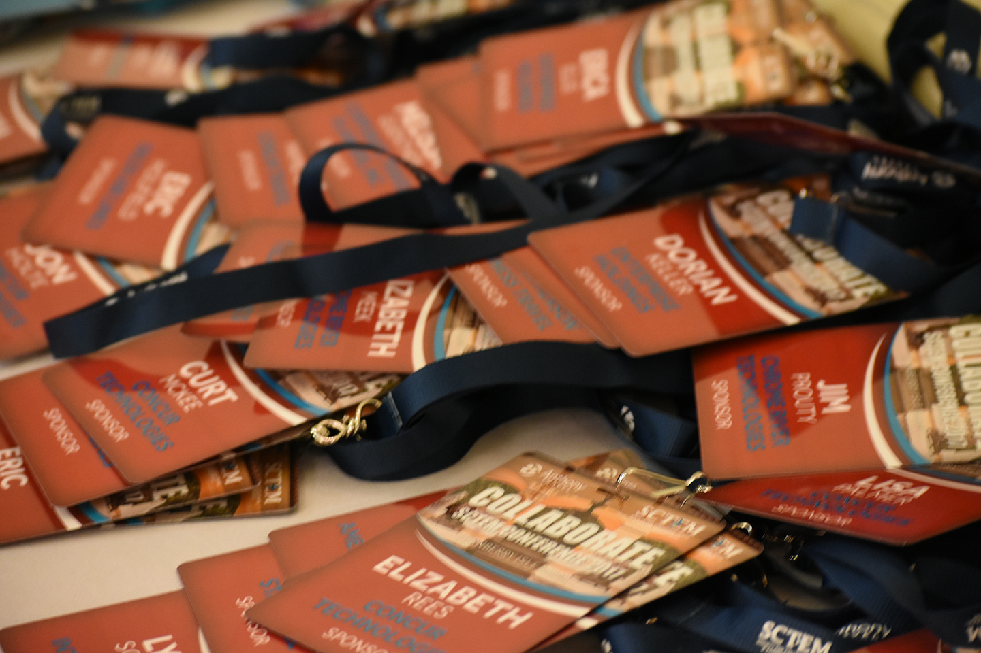

Diamond (Sold)
$25K: Keynote Session Speaker: By sponsoring our keynote speaker, Sponsor is provided opportunity to introduce speaker with 2 minute speech on their product/service (“elevator speech”); acknowledged as our top sponsor for the conference; Digital Marketing Package - Diamond; 5 free registrations; Table at Vendor Speed Dating; trade show table.
Platinum
$20K: Dinner (2 available): By sponsoring dinner, Sponsor is provided opportunity to host the dinner (meet & greet) and give 2 minute speech on their product/service (“elevator speech”) during dinner; acknowledged as one of our top sponsors for the conference; Digital Marketing Package - Platinum; 4 free registrations; Table at Vendor Speed Dating; trade show table.
Gold
$15K: Lunch (2 available): By sponsoring this package, Sponsor is provided opportunity to host the lunch (meet & greet) and give 2 minute speech on their product/service (“elevator speech”) during lunch; acknowledged as one of our top sponsors for the conference; Digital Marketing Package - Gold; 3 free registrations; Table at Vendor Speed Dating; trade show table.
Silver
$10K: Educational Session Sponsor (6 available): This sponsorship funds a scholarship for an educational session speaker. Sponsor is provided opportunity to introduce speaker with 2 minute speech on their product/service (“elevator speech”); acknowledged as a sponsor for the conference; Digital Marketing Package - Silver; 2 free registrations; Table at Vendor Speed Dating; trade show table.
Bronze
$5K: Breakfast (3 available): By sponsoring this package, Sponsor is provided opportunity to host the breakfast (meet & greet) and give 2 minute speech on their product/service (“elevator speech”) during breakfast; acknowledged as one of our sponsors for the conference; acknowledged as sponsor for the conference; Digital Marketing Package - Bronze; 1 free registration; Table at Vendor Speed Dating; trade show table.

$5K: New Attendee Reception (1 available): By sponsoring this package, Sponsor is provided opportunity to host the Reception (meet & greet) and give 2 minute speech on their product/service (“elevator speech”) during the Reception; acknowledged as one of our sponsors for the conference; Digital Marketing Package - Bronze; 1 free registration; Table at Vendor Speed Dating; trade show table.
$5K: Reception (2 available): Receptions are the 45 – 60 minutes prior to dinner each night. By sponsoring this package, Sponsor is provided opportunity to host the Reception (meet & greet) and give 2 minute speech on their product/service (“elevator speech”) during the Reception; acknowledged as one of our sponsors for the conference; Digital Marketing Package - Bronze; 1 free registration; Table at Vendor Speed Dating; trade show table.
$5K: Conference Bags (SOLD): By sponsoring the conference bags, Sponsor will have their company logo on the bags which will be provided to all attendees; acknowledged as one of our sponsors for the conference; Digital Marketing Package -Bronze; 1 free registration; Table at Vendor Speed Dating; trade show table.
$5K: Wednesday Excursion (1 available): By sponsoring this event, Sponsor is provided opportunity to host an optional excursion after the conference wraps up; details to be determined. Digital Marketing Package - Bronze; 1 free registration; Table at Vendor Speed Dating; trade show table.

$5K: Trade Show & Break (2 available): By sponsoring this event, sponsor is provided opportunity to host a trade show and break; acknowledged as one of our sponsors for the conference; Digital Marketing Package - Bronze; 1 free registration; Table at Vendor Speed Dating; trade show table.
Vendors are encouraged to invite/sponsor EDU attendees. Your current clients add value by: 1) bridging relationships between vendors and potential EDU clients, 2) marketing your product/service by providing in person testimonials.

