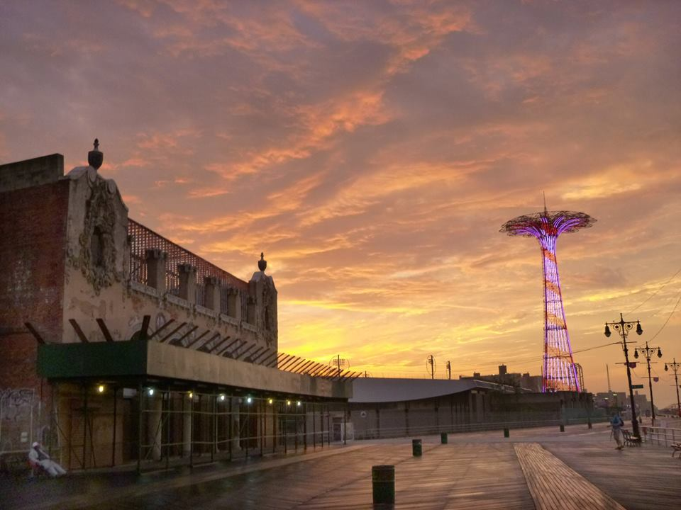  Duty of Care  Travel Risk Management for Travelers | Abstract  How companies can meet their duty of care obligations and drive Duty of Loyalty. Includes a crisis simulation exercise and curriculum for traveler education.  Paul Laherty

Contents
Duty of Care 2
Initial Steps for Travel Management Teams 3
Create Duty of Loyalty 3
The Safest Room in Any Hotel 4
An Armored Car Primer 5
Source High-Security Vehicles 6
Travel Risk Management Providers (Medical and Intelligence) 6
Kidnaping, Ransom and Extortion 7
Satellite Phone Providers 7
Crisis Simulations 7
Scenarios and Case Studies 8
Simulation Exercise for Universities 9
Crisis Decision-Making and Command Center Operations 11
Crisis Management and Care Teams 11
Traveler Support 13
Case Studies 14
Greensburg, Kansas. 14
Islamabad Marriott Hotel. 14
South Korea, MV Sewol. 15
Mumbai, India 16
Mayalasia Airlines Flight 370. 16
Develop an Armored Attitude 17
Curriculum for Road Warriors 18
Practical Travel Risk Management Principles 19
Pre-Trip 19
Packing Plan 19
Flying 19
Arrival 20
Ground Transportation 20
Hotels 21
Out and About 21
Bibliography 22

Duty of Care
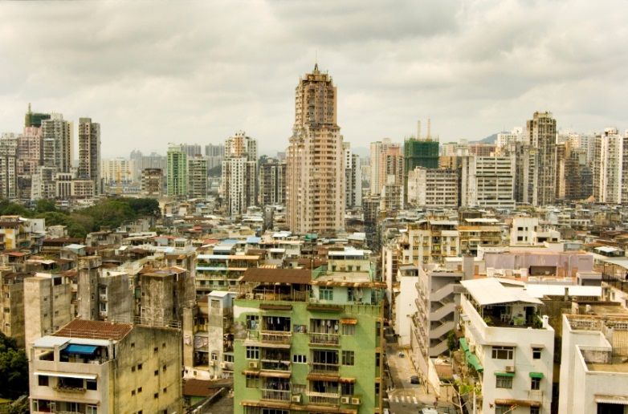
Duty of Care is the idea that Corporations are responsible for the security of their employees during travel and when engaged in activities that support the company’s interests. The European Union’s Duty of Care Act is the most prominent regulation in Europe to codify this requirement. The EU spells out how companies should behave regarding employee safety and security, but the United Kingdom took this a step further with the UK Manslaughter Act (Telegraph, 2011) that allows companies to be held criminally liable for harm that come to their employees. The regulation applies to UK employees abroad, or the non-UK Company employees while they are in the UK to conduct business.
These regulations jump-started the Duty of Care industry in Europe and North American Corporations are still playing catch-up. Duty of Care describes the set of behaviors, planning, and actions companies must take to safeguard their employees.
Duty of Loyalty is the concept of employee compliance with their employers’ efforts on their behalf. If a company makes a car service available, or requires employees to meet minimum safety guidelines, Duty of Loyalty is the force that compels an employee to meet those standards. Companies that go out of their way to create a high quality of life during employee travel and are proactive about serving travelers on the road will generate much higher loyalty. Companies undermine their employees’ loyalty through cumbersome or overly-restrictive policies and should strive to strike a balance that rewards loyal behavior while not driving the employee to another company.
Nature, crowds, and criminals can overpower people and technology. Travel departments manage population statistics and risk factors before an event occurs. Corporate Security takes over after and event; you must be partners to achieve the best outcomes.

Initial Steps for Travel Management Teams
Every manager is responsible for employee safety at work, including trips between sites that don’t flow through the travel management group. Trips between a manufacturing plant and a supplier nearby fall into this category, but your organization may also be liable when a traveler tacks on a private tour to Petra, Jordan, after attending a conference in Istanbul. Travel Management and Corporate Security should work together to provide reports and business reviews that cover travel risk, employee health, on-duty accidents, and ‘near’ misses, to a steering committee that includes representation from Executive, Human Resources, Legal and other operating divisions and groups as necessary. At a minimum…
- Establish policies to protect travelers in high-risk locations and mission-essential personnel anywhere.
- Create procedures for travelers to add passive segments easily. Use this as a KPI to measure Duty of Loyalty and report it across the organization.
- Provide travelers with information about potential threats several days before travel.
- Publish information about after-hours service to support medical or travel emergencies and include phone numbers for international access.
- Publish your security team’s phone number and distribute it with every itinerary.
- Implement a traveler education program.

Create Duty of Loyalty
A sound Duty of Care program arms your employees with knowledge, skills, and resources to avoid problems on the road and respond appropriately when something breaks down. Employee training must focus on specific risks your top travelers may face. They need to know about the support available and who to call for help. Duty of Care must be traveler-centric, it’s not about management policies – focus on employee outcomes.

The Safest Room in Any Hotel
You will find the safest rooms on the third and fourth floors away from the front of the building and at least one room away from elevators or stairs. Why? Simple – fire. The most common, fire truck carried, tallest, three-section ladder only extends forty-feet, and weighs 220 pounds.
Fire can spread through stairwells and elevator shafts quickly so a buffer room is a good idea and high rooms cannot be reached with most ladders. It’s easy to remember to stay low in case of fire, but most people don’t understand how quickly the super-heated gas a few feet above the floor can cause severe burns to delicate lung tissue. Think about the heat you feel from an oven at 350°F? Now think about what one deep breath of air heated to 900°F could do? Carbon Monoxide is another serious threat, fortunately, extreme heat and carbon monoxide are both found up high, so keeping your head below door knob height will give you a much stronger chance for survival. If you need to leave your room during a fire, don’t use elevators and don’t leave skin exposed; put a wet, cotton t-shirt around your head, and a pair of cotton socks on your hands as an impromptu pair of gloves. Touch doors and doorknobs with the back of your hand before you open them, and don’t stand in front of the opening until you know it’s safe to do so.
Unfortunately terrorism is another risk hotel guests face; room locations away from the building’s main entrance tend to offer better protection against Blast Overpressure Exposure (BOP) and projectiles. Blasts occur disproportionately on the street level in front of the lobby entrance. In high risk locations it makes sense to keep your drapes closed to catch broken glass, and sleep on the bed away from windows. You should also remember to carry a small doorstop with you and secure your room when you’re in it.
A few more hotel tips – it’s a good habit to make your first trips to the lobby via the primary and alternate emergency exits closest to your room so you’ll be familiar with them should you need to use them in the dark. This isn’t a comprehensive response list, but adopting these habits will give you an advantage if you’re ever faced with an emergency or crisis while you’re away from home.

An Armored Car Primer
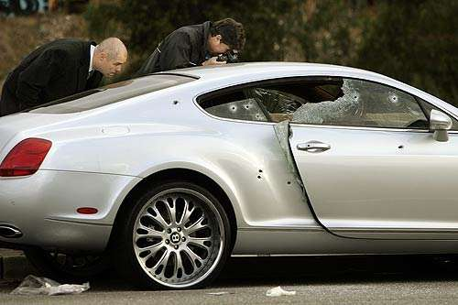
The US State Department issued a Venezuela travel warning in November 2013. They published a requirement for their staff to use an armored car for travel in certain parts of the country or at night. They provide a thorough description about the current risks to travelers in Venezuela - security managers and travel professionals should be familiar with it (Venezuela Travel Warning).
Armored vehicles offer flexibility and options for travelers that conventional vehicles do not (Oatman, 2006), while operational experience suggests business travelers employ low-profile vehicles - not up-armored Chevy Suburbans. Corporate travelers need to blend in - and sophisticated executive protection companies with local knowledge can help you avoid trouble. Armored vehicles weigh much more than their showroom peers so a professional driver is recommended. Local drivers are also valuable for their area knowledge and experience in different situations. They're more likely to identify threats before a traveler would, and they can use alternate routes with information a GPS doesn't have. Finally, a driver provides a layer of indemnification and protection from liability in case the vehicle is in an accident.
Traditional armored car manufacturers use steel plating and bullet-resistant glass to protect the people inside, while contemporary construction replaces steel with polyethelene-based materials. Spectra and Dyneema are the most common - and are superior to Kevlar; a Spectra-enhanced vehicle is frequently 1,000 pounds lighter than the same vehicle protected by steel, so handling, acceleration and braking performance are much better. Although Spectra vehicles are lighter, a trained driver is still a good idea; they can get the most out of any car through evasive driving techniques and features unavailable to the average driver. Unfortunately, duties and taxes on imported vehicles drive costs up and favor local manufactures who apply hardened steel. A $200,000 vehicle from industry-leader Texas Armoring would cost almost $400,000 in certain markets. View http://www.texasarmoring.com/ for more information about their products and Spectra.

Protection levels for non-military vehicles are shown below:
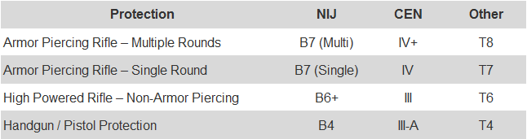
Armor is available in many shapes and sizes across a range of vehicles, but protection is measured using a comparative scale that considers how much energy it can absorb, the type of ammunition and number of rounds. Manufacturers and operators apply different scales issued by the National Institute of Justice (NIJ), the Central European Norm (CEN) and other organizations. Vehicle rental prices are based on the protection requirement. More armor means more weight, thus higher levels require the biggest platforms (BMW 7 Series, or full-size trucks like the Toyota Land Cruiser and Chevy Tahoe) – don’t expect B7 in a Camry. Conversely you should verify the Tahoe you rented offers B6+ or better protection. In high risk areas – including Latin America B7 is a minimum, while B6+ might be acceptable in the US and Canada.

Source High-Security Vehicles
Most five-star hotels can offer introductions to local security companies that will provide armored vehicles in their market. Prices typically start at $500 per day. Global providers, like Diplomat Armored Rental, offer a single-source for vehicles in Caracas and around the world. See diplomatarmored.com to find cars available in many countries. They offer Chevy Suburbans, Ford Explorers and Toyota Prados in Venezuela. Prices start at $1,500 per day and include an armed, high-security driver, trained to provide high-risk protection and drive a heavy, steel-plated vehicle. You can also reach out to your TRM supplier for advice. Plan ahead and gather details about the car, the armor, the driver's training, credentials, and photographs before you send your travelers into high risk locations.

Travel Risk Management Providers (Medical and Intelligence)
Security is always part of my pre-trip planning so before a series of trips to high risk locations I compared medical evacuation, legal, and security support providers. I contacted Travel Guard, International SOS, iJet, and the Anvil Group to compare their products. Remember, “Insurance is not a substitute for 9-1-1, and most of the time travelers must be their own first responders.
The providers:
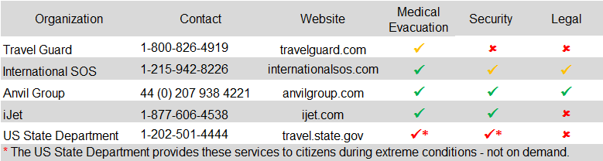
Each company provides medical advice and support traveler evacuation in an emergency. International SOS is the clear leader in this category, while Travel Guard has a stronger focus on insurance.
The Anvil Group offers a range of products that fit my ideas about security, and include medical care as part of their emphasis on travelers and Executive Protection. They are clear front-runners if you’re looking for personal protection - from a driver through a VIP security detail.
At a minimum travelers and companies should be knowledgeable about the US State Department's Smart Traveler Enrollment Program (STEP). It offers many of the benefits available through for-profit providers, but emergencies that drive high contact volume (terrorism, typhoons, Earthquakes, Volcanoes) will put you in a long queue so private providers double your odds for support - and they'll discuss options if you find a need for their services in-transit. Travel Executives should manage traveler education and awareness training to establish their role in pre-trip education and risk avoidance and mitigation. Once an event happens Executives often huddle with legal, risk management, and security, to the exclusion of other affected groups. A well-designed, consistent program will enhance the Travel Departments role and secure a seat at the table – the purpose of your participation is to offer sound recommendations about travel, vendors, and other topics you’re an expert in. You become a communication channel to your partners about the organization’s needs and expectations in the coming hours and days.

Kidnaping, Ransom and Extortion
KR&E protection is a special case, check out Michael Guidry at www.Guidry.com, for KR&E Insurance and negotiation protection. Terra Firma Risk Management is another company that specializes in KR&E negotiations; insurance can be purchased through the XL Group and AIG. Learn more about negotiation considerations here.

Satellite Phone Providers
In a crisis with widespread damage and those that take many days to resolve, land-based systems may fail – including cell towers and phones, internet providers, basic utilities and transportation. Hurricanes provide many examples where communications, power, clean water and liquid fuels become scare immediately before and for many days after the storm passes. Satellites provide communication capabilities in situations when cellular networks are down or out of reach. Companies don’t need to provide a phone to every employee or traveler, but a few satellite phones available as a shared resource can provide extra piece of mind and way to reach employees when other methods fail.
Phones cost between $600-$1,700 and around $1.00 per minute for calls. Three major providers:
- Iridium
- Inmarsat
- Thureya.

Crisis Simulations
Experienced Military Commanders, Police, Fire-Fighters, and business leaders have their own examples to demonstrate how a combination of high stress, intense workloads and difficult and unusual situations create challenges that reduce effectiveness. Thorough planning and rehearsals that replicate ‘real-world’ scenarios can identify policies, friction and obstacles that could interfere with your organization’s response during a crisis.
Pre-crisis planning begins with simple Emergency Procedures books kept at the main reception desk. The procedures manual should contain checklists for a variety of emergencies including: Fire, Medical Emergency, Severe Storm, Power-Outage, Bomb Threat, Suspicious Package, Suspicious Person, Suspicious Vehicle, Visitor Policy, After-Hours admission policy, and Lost ID. Corporate Security, Risk Management, or Corporate Real Estate owns, audits and updates the Emergency Procedure books as part of their organizational responsibility - procedures should be “exercised” during fire-drills or rehearsals for other emergencies.
At the other end of the Crisis-Simulation spectrum is a multi-day, multi-organization, mass-casualty drill that includes State and local police, fire-departments, regional hospitals, federal law enforcement, FEMA, the Red Cross, and many “actors” used to test logistics, communication, and crisis management resources. Less resource intensive table-top exercises, or “sand table” exercises are multi-hour coordination meetings that combine leaders from across an organization to review a scenario as it unfolds. Each participant should describe how they would respond at different stages and as new information becomes available. This gives participants a chance to review policies each department may use to guide their answers.
Simulations create an opportunity for other groups to ask questions, explain themselves, and coordinate responses that may conflict with another group’s views or recommendations. Table-top exercises are meant to be inexpensive, knowledge-rich, simulations that benefit from participants undivided attention. Scenarios should be plausible, wide-ranging and high-impact. Use a moderator to introduce participants to the simulation methodology and develop the scenario through surveys several months before the event. An effective scenario should test known and expected gaps, and uncover new gaps in the organization’s ability to respond in a crisis.

Scenarios and Case Studies
Most travel crises will affect one or a few travelers, and can be resolved in a few days without disrupting the organization. The single biggest event recently – the Eyjafjallajökull volcano stranded thousands of travelers on the “wrong” side of the Atlantic Ocean for more than a week. For most travelers this was an inconvenience that patience and a credit card could solve so should not be described as a crisis, although it increased workloads for Travel Management teams at many companies.
Unfortunately not every crisis will allow your business to go on as usual. It’s instructive to study the circumstances surrounding actual events and use them as a guide to review how your policies and organization could have responded to a similar event. This discussion will focus on terrorism and transportation accidents since they often affect a large number of travelers for several weeks.
- Attack in Mumbai – Unilever India’s Board was meeting at the Taj Hotel – the entire Board was affected.
- MH370 – Twenty employees from Freescale Semi-Conductor were on the flight.
- The MV Sewol – More than 300 students from one school, and most perished.
- Bus accident in Orland, California – 30 prospective students on a college visit organized by a University.
- Islamabad Marriott bombing – More than 300 casualties, most with serious injuries, and 54 fatal.
Key findings:
- Mumbai – Employees barricaded themselves in a 2nd floor ballroom. Hotel security was inadequate to defend against a determined attack by several gunmen. The fire-department was unable to help people escape or to extinguish the fire. Board-Members had been trained to respond before the event; they did not wait for help to arrive before taking action that saved their lives.
- MH370 – Freescale Semiconductor will not comment about losing 20 employees. A reasonable response likely includes flights and hotels for 100-200 family members, and multiple trips by other employees. Did they create family-advocates and reassign employees to assist employee’s families? It’s reasonable to assume they have multiple employees assigned over several months, plus lawyers, corporate communications, and outside PR and Legal. How did the employees’ departments cope with their losses? How many "near-misses" did you have? Counted as same flight number, different days, or different flight numbers, same day?
- MV Sewol – Students were ordered to put life-vests on and stay below deck. The few who ignored crew-member instructions and moved to the high-side deck survived. Another example where the victim becomes their own rescuer. Over 300 fatalities. Unclear who paid for the victims’ parents and other family-members to travel 200 miles from home. Although victims were children it’s not a stretch to examine the financial implications for a University or Company.
- Bus accident in Orland, California – Like MV Sewol, and MH370 – family-advocates should be assigned and immediate transportation to the accident scene for several dozen family members.
- Islamabad Marriott Bombing – The blast destroyed the hotel and everything in it. Something interesting happened; since many rooms had gas heaters when the blast ruptured the feed lines it started a gas-fed fire inside the building. Compounding that problem, the fire-suppression system was badly damaged and was ineffective against the fire. Survivors had to cope with their own injuries, darkness, debris, and fire. The blast created a debris field and crater that prevented fire trucks from reaching the building until wrecked cars and concrete were moved. Did you have near misses?
In each case – survivors became their own first-responders. In only one case, the Islamabad Marriott Bombing, would an intelligence briefing have suggested an immediate threat. Traveler tracking is useful to know your employee or traveler is on a flight, bus, ferry or in the hotel, but it could neither provide their status nor allow you to send them an updated itinerary.
How would a traveler react after reading this text: “Incident in Pakistan: Please call for assistance, we are standing by to help, or make changes to your itinerary as needed – the travel team.” What could you do for them from 7,000 miles away? How would a traveler feel about this one instead? “Incident in Pakistan: Call if you need assistance from us. Your family has been assigned an advocate to provide support while you are away.” Familiarization with travel department resources can give your travelers piece of mind and generate Duty of Loyalty.

Simulation Exercise for Universities
In its briefest form, the simulation should last about four hours. Allow two hours to develop the scenario, followed by a break, and then an hour to conduct an after-action-review (AAR). During the AAR, each report and internal update should be reviewed. The “responsible” group should acknowledge their responsibility to act on the information, and explain what they did. Focus on what was handled appropriately, what went well, and what could use improvement. Each participant should be encouraged to share their observations and opinions about what occurred.
The AAR process should produce a list of recommendations about policy changes and provide participants with experience about command & control and decision-making in a crisis without perfect information.
“Yesterday, while driving to the NCAA Basketball tournament in Memphis, the University’s Women’s Basketball Team was involved in a serious traffic accident. One bus collided with a tractor-trailer and was struck from behind by the second bus. The Tennessee State Police are coordinating on-scene, but no further updates are available."
- +15 Assistant Coach 2 (AS2) called. AS2said he saw paramedics put the head coach (HC) in an ambulance.
- +25 Team Physician (DR) called to say he is in the ambulance with the HC. Severe head and chest injuries.
- +30 CNN showing video of four helicopters on the highway, several dozen emergency vehicles. One bus on fire.
- + 35 CNN reporting multiple casualties.
- +36 Two parents called to say their children-players are enroute to Memphis Regional Trauma Center. Condition unknown.
- +38 Parents – driving with the team busses, stated another parent carried two players by POV to a local hospital – do not know which one
- +40 NCAA called to offer assistance.
- +41 Governor called to offer assistance.
- +42 CNN reporting four dead, multiple enroute, extractions in progress.
- +43 Twitter: #MemphisCrash Trending.
- +45 Facebook: Player 6 posted pictures reported to be Player 1, Player 2, apparently uninjured standing near a police car.
- +45 AC2 called to report Player 3, & Player 4 deceased. Also reported TD transported with head and chest injuries,
- +46 University Police traveling with the team called: multiple fatalities, Player 3, Player 2, HC is critical, Player 1, Player 5 OK.
- +50 University Police report Memphis Regional Trauma Center (H1) have admitted ten, three via careflight, six by ground ambulance, one by POV. No names available.
- +51 NCAA called to ask for details about press conference? Will it be in Memphis or at University?
- Repeated calls to Athletic Director are unanswered.
- +55 Twitter: #RallyForOurTeam is trending. Students are beginning to meet in the street in front of the Student Building.
- +55 Twitter: #MemphisRally is trending. Student crowd is forming around Memphis Downtown Marriott where team was planning to stay.
- +60 CNN: Reporting that team bus driver posted a facebook picture of the team from his seat 1 minute before the accident.
- +61 Governor called, needs casualty update.
- +65 AD called, needs details for a press conference in Memphis. How is HC?
- +65 Booster President called, wants details about where Player Parents should meet?
- +66 Parent 1, Parent 3, Parent 4, Parent 7, Parent 9 – what’s going on?
- +70 Student crowd has shut down vehicle traffic through campus…
- +71 H1 called. Player 8 deceased – Identity confirmed by AC2.
- +72 AC2 called, Player 8 parents are not in Memphis???
- +73 CNN report: At least 4 dead, including Driver 1; they’re displaying picture of D1’s facebook page, which contains photo of University Team on a bus. D1 reportedly involved in fatal traffic accident 16 years earlier.
- +75 H1 called: HC in surgery, prognosis good, collapsed lung, spleen removed, minor abrasion on his head.

Crisis Decision-Making and Command Center Operations
A command center should be established to organize and disseminate information and support decision-making by the leadership team. It’s a communications hub. The leadership doesn’t need to be present physically, but a command center is the place where decisions, information, and work by each group can be shared with others quickly. Each department should designate an operational team to support the organization’s mission, and the command center should house a department coordinator, while the department-heads remain with their organization.
In practice the COO would house a response team in his offices, while the head of Manufacturing would remain with her team. They would meet at periodic, scheduled “Command Center Briefings” that might occur twice each day during the first days following an event, and less frequently later. The point is senior leaders don’t need to camp-out in the command center, but it’s a best-practice for press conferences to occur immediately following senior leader briefings, where organization-level decisions can be made privately, but shared publicly as soon as possible. The crisis leadership team must determine who will coordinate with multiple groups:
- Victims
- Staff
- Leadership
- Parents
- Students
- Media & the Public
- Government Officials and external organizations
It’s helpful to construct a “responsibility and response” matrix, that lists people and organizations that the crisis team needs to coordinate with. A report “Tracking Board” is another helpful tool that keeps information organized for multiple users about different situations. Information contained about reports should include: time/date, and who reported; report details, contact details; time next report is due; verified (yes/no); status (Confidential, Public); Shared with media (Yes/No). Details should be added or ignored as necessary.

Crisis Management and Care Teams
Every crisis entangles the victims in predictable ways. There’s a time component that must be considered, whether it’s an acute illness, a traffic accident or civil unrest, the traveler’s condition and location will have a large effect on their job performance, coworkers, and family. The responding organization must coordinate a response based on supporting the traveler’s needs and consider the effects on their families and work groups over time.
Research focused on medical malpractice suits demonstrates that patient outcomes are not the best predictor of a later claim, rather perceptions about the Doctor’s bedside manner was more highly correlated with patient satisfaction and the risk of a lawsuit. So it goes with customer service. Organizations that take responsibility and own their actions seem to have higher Net Promoter Scores (NPS). Extending this insight to Duty of Care policies leads to other examples.
Large network carriers have teams dedicated to aircraft crash events. American Airlines leads the industry and has several hundred employee volunteers who are registered “CARE” team members. When an incident triggers a CARE team response, the airline establishes a command and coordination center near the accident scene, and assigns one employee per traveler and one for their family – at any location. CARE team members are given complete freedom to support victims’ families including travel arrangements and costs to cover incidentals at American’s expense. Victims’ families are immediately given $25,000, without obligations, to cover near term expenses. This is a gesture intended to help survivors and shows good faith on American’s part.
Support is not a check to replace a lost iPad, or missing luggage. Insurance is not a substitute for 9-1-1, and most of the time travelers must be their own first responders. Support is the lawyer who appears at the local police station after an impaired driver destroyed your rental car and shoved it onto a crowded sidewalk after running a red light. It’s the paramedic who ran into the local clinic to have your co-worker moved to a private clinic in the Capital before someone else could make a life-changing decision about his or her treatment. Support is not insurance coverage that pairs your travelers with someone who met the minimum standards for their profession. When it counts travelers need an expert. Money is not the limiting factor in situations you should avoid. Think Mr. Wolf from Pulp Fiction. Travelers are their own first responders and they need to know.
Too often they don’t. Examine the recent tragedy in South Korea. Nearly 300 High School students perished in a survivable accident. The ferry they were riding in to attend a school trip began to take on water; the crew instructed passengers to don life-jackets, but to “stay calm” and remain below deck. Passengers had the power to ignore those instructions and move top-side or to an outer walkway that would have given them access to the ocean once the vessel began to sink, but many of them followed instructions and went down with the ship.
Another example comes from the terrorist attacks in Mumbai in 2009. Mr. Polman, CEO at Unilever plc, was attending a dinner at the Oberoi Hotel in Mumbai when it was attacked. Luck and recent training helped him and the board of Unilever India escape from a terrifying situation (Hope, 2009). That experience drove important changes at Unilever and Duty of Care and Travel Risk Management efforts are supported at the highest levels across the organization.
There’s no substitute for planning - annual table-top exercises that include Travel, Travel Operations, Legal, Corporate Communications or Press Relations, Corporate or Campus Security, Risk Management, and Executive sponsorship will give you important information about your capacity to handle a major crisis. Your planning should involve scenarios that test your resources, approval authority, and stamina.
Freescale Semi-conductor had 20 employees on Malaysia Airlines Flight 370 – this was a large scale event that impacted many employees, and the crisis continued for months. Another instructive example is the bus crash in California’s Central Valley in early 2014. A FEDEX tractor-trailer crossed the centerline and destroyed a charter bus operating for California State University Chino, to bring prospective students on campus for tours. How would your team manage the aftermath? What if it was your women’s basketball team, or a student association? How many of your Colleges and Universities send choirs and athletic teams to Europe every year? The Middle East? Do chaperones know what to do if a student kills someone else in a car accident?
You are responsible for coordinating activities – you may not lead the incident command center established to respond to families, friends, travelers and victims, but you are integral to the process and your normal travel policy and guidelines should be set aside in favor of higher service levels and greater flexibility.

Traveler Support
You manage thousands of travelers – crisis will only affect a small percentage of your total, but education, awareness, and outreach should cover all of them. Traveler Tracking – how can you support travelers if you don’t know they’re not at their desk? Managed Travel Programs’ primary benefit is providing consolidated travel spend to leverage during supplier negotiation. But…when the CEO, the President, or the Governor calls to ask who was on that flight that just went down you need to quick access to the latest PNR data to show you who was on Malaysia Airlines flight 370.
Most Travel Management Companies and International SOS offer “Traveler Tracking” through a variety of branded or private-label tools. Cornerstone Information Systems is the best in the business and is the power behind several of the most widely used tracking tools in the industry. Their iBank® corporate reporting suite contains a tracking feature that can query Global Distribution System (GDS) queues every ten to fifteen minutes and provide Travel Managers with up-to-date information about where their travelers are scheduled to be.
You’ve already read about situations that show how traveler-education can improve outcomes. So how do you determine who should attend training? Easy – tClara’s Trip Friction scores. Scott Gillespie is a travel management expert. His company, tClara, offers a traveler scoring model that incorporates variables that correlate to risks and traveler wear-and-tear. He calls it TripFriction. Travelers who take redeyes, fly in coach, depart on the weekends, or otherwise find ways to make their lives more difficult, receive credit in Scott’s model. A first-class flight from Dallas to LaGuardia at 11AM really isn’t that difficult, but a Saturday afternoon departure from Washington, D.C. to San Francisco, in coach, to connect to a Sydney-bound flight creates stress, especially when your traveler will head into a meeting two hours after landing. tClara will rank-order all your travelers and give you information about who you need to focus on – either for additional airline perks or for training. Traveler Tracking and TripFriction Reports are a great start, but throwing in crisis-simulations, and traveler training will put you far down the Duty of Care path and on your way to become a world-class organization.

Case Studies

Greensburg, Kansas. May 4th, 2007, F5 tornado, 12 dead.
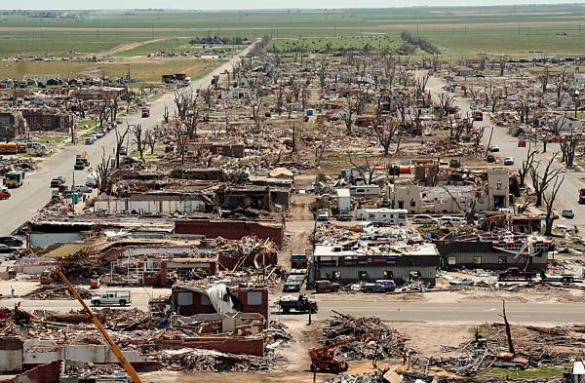

Islamabad Marriott Hotel. September 20, 2008 - bombing, 54 dead, 266 injured.
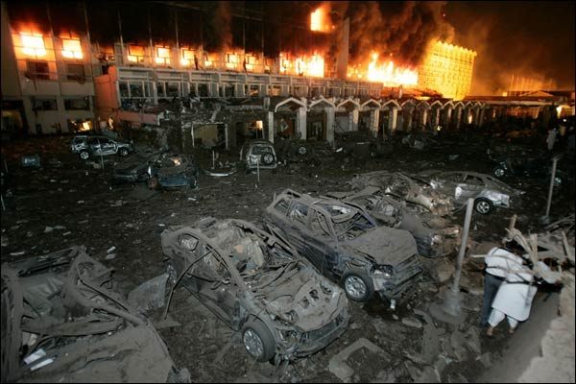

South Korea, MV Sewol. April 15, 2014. Ferry sank with 476 People aboard, 304 presumed dead.
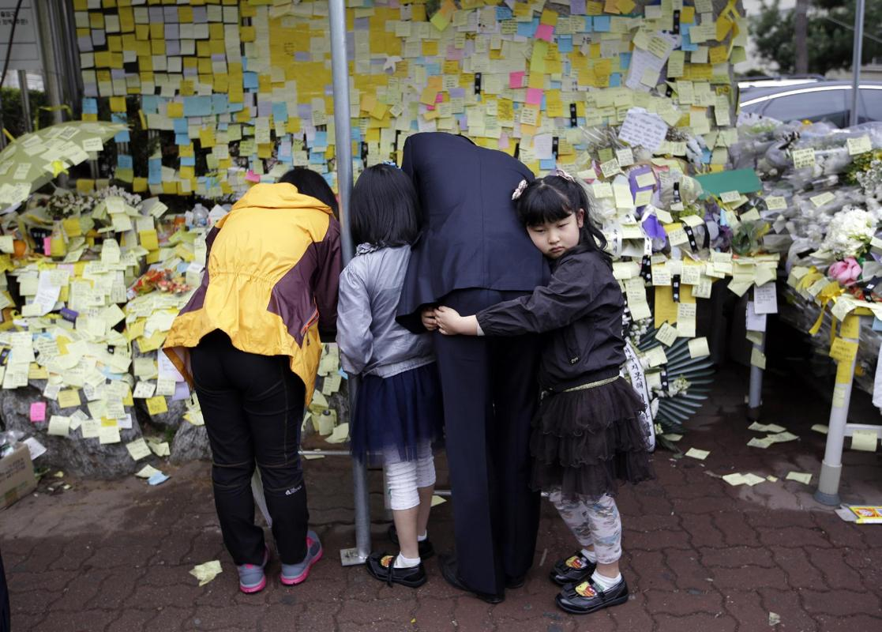

Orland, California. April 11, 2014. A Fedex tractor-trailer and a tour-bus collided - 10 dead.
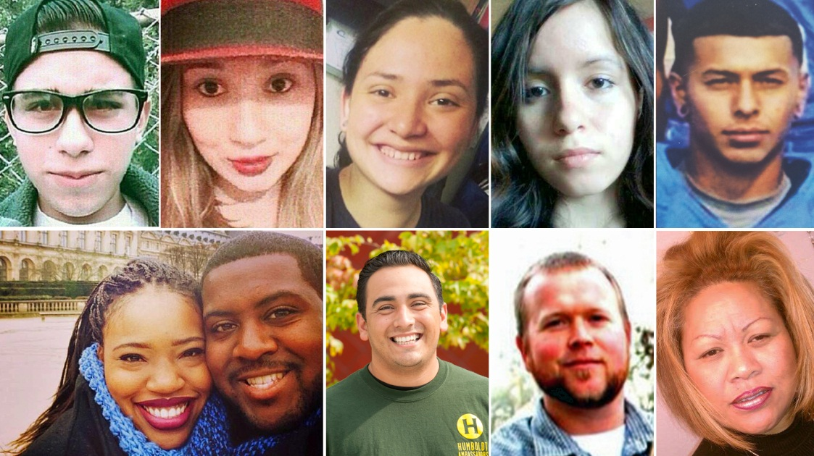

Mumbai, India. November 26th-29th, 2008. Terrorist attack. 166 dead.

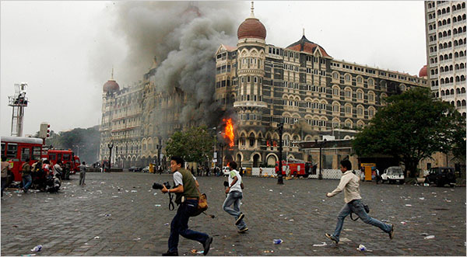

Mayalasia Airlines Flight 370. March 8th 2014. 239 presumed dead.

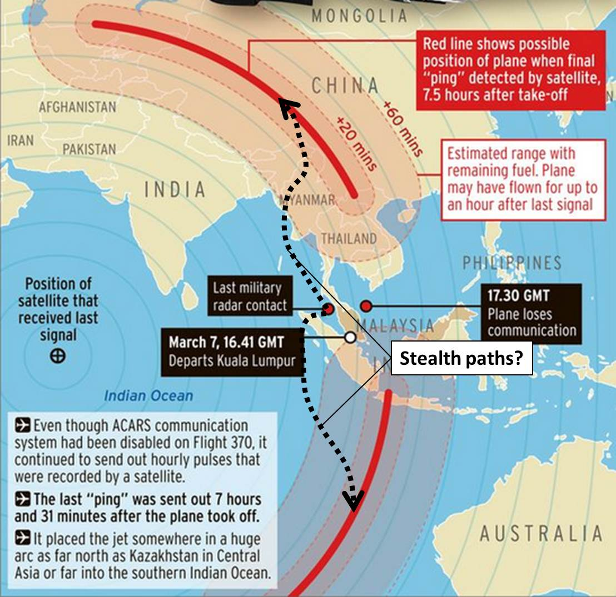

Develop an Armored Attitude
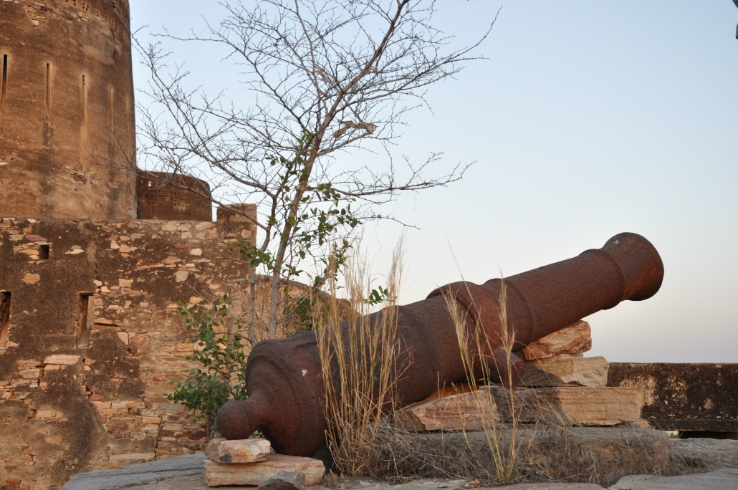
Attitude is the most important ingredient for survival and security. Survivors share a realistic belief about their capabilities and likely outcomes. Survivors trust intuition and have the right attitude to take action. Awareness is another powerful ingredient. Awareness is the mental preparation and the dynamic evaluations people make as they move through space – often called situational awareness. Awareness isn’t sufficient to find a solution in high risk situations or events. Awareness is a starting point. High awareness gives you an edge and allows you to consider alternatives as risk increases, meanwhile attitude is the motivation layer that guides you to safety. Survivors thrive because they understand that 9-1-1 is never immediate – it’s only a back-up. Survivors with an Armored Attitude understand that Police and Fire Fighters are Second Responders.
Travelers must be their own First Responder. Cheerleaders are people who let their guard down when the cavalry shows up (Sherwood, 2009). Survivors keep going, they don’t stop fighting until there are no choices left to make. In Tim Larkin’s book, How to Survive the Most Critical 5 Seconds of your Life, (Larkin & Ranck-Buhr, 2009) Tim asks how you would feel if a muscle-bound 300 pound man was paid to harm you? He doesn’t ask if you could defeat this opponent, only if you could “touch” him. It’s easy to imagine that you could put your hands on him, but harder for most people to envision walking away from the encounter. Tim teaches you how. It’s that attitude that gives travelers an edge. Tim’s program, TargetFocusTraining, teaches exceptional skills to average people that will help them develop an Armored Attitude.
Violent weather, mechanical failures, bad luck, criminal mischief, and civil unrest swallow targets everyday on any part of the globe. No matter where a threat comes from or what form it may take, an Armored Attitude combined with good situational awareness will give you an edge that may be the difference between an interview with you than an interview about you.

Curriculum for Road Warriors
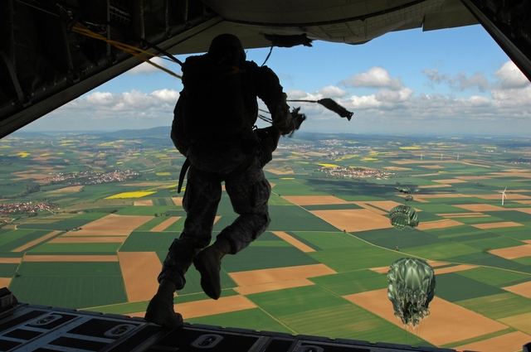
- Review Duty of care / Duty of loyalty
- Risk management: population statistics and measurement tools.
- Travel risk drivers – causes, probabilities, and responses
- Travelers need to know what resources are available for them, and how those resources will connect with them.
- How does your travel team know where you are?
  - Methods – traveler tracking via GDS Queue, GPS ring-fencing, traveler check-ins, active outbound calling to the traveler, VIP Security Teams.
- Medical, Travel, and Legal support available.
- Communication devices – Satellite phones, PLB’s.
- VIP kit bags – Vest, PBE, PLB, SAT phone, First Aid; including driver and VIP transport
- Personal travel kit.
- How to respond to a non-criminal crisis – consider type, location, and sensitivity to employee-level.
- Weather events.
- Accidents
  - Vehicle
  - Other accidents
- Illness – acute, persistent, poisoning.
- Fires.
- How to respond to a criminal crisis – Describe roles for people, locations, and traveler behavior.
  - Target selection.
  - Assault, Theft, Kidnapping, property crime.
  - Avoid or Respond.
  - Civil unrest.
  - Terrorism.
  - Threats, bombs, and assaults.

Practical Travel Risk Management Principles
Personal security in the real world starts with your employees. It’s great to have Navy Seals and Special Forces consultants demonstrate the latest hand-to-hand combat techniques, and defensive driving in up-armored Suburbans with run-flat tires. …But, security designed for the CEO does little to help the intrepid sales person walking through the commercial district in Buenos Aires or London with a Starbucks coffee in one hand and the latest smartphone in the other. There are simple principals that, when followed diligently, can increase your employees’ safety hundreds of percent. Consider these suggestions and best practices before you leave home or send employees to far-flung corners of the earth.

Pre-Trip
- Use TripAdvisor or other online service to research locations, customs, tipping guidelines, and the weather.
- Review the US State Department warnings and reviews for countries and regions you will visit.
- Always have a copy of every confirmation number, hotel address and phone number. You will need it at some point. Paper beats digital in most places, especially India. Traxo, TripCase and TripIt offer free solutions to get you organized.
- If you will use a tour-guide, when possible, negotiate itineraries, fees and prices upfront. You should have control over your timeline and every place your guide will take you including planned restaurant stops. Demand no add-on's while touring to avoid local craft centers or “kick-back” shops where an exorbitant bill is delivered and the restaurant splits the check with your guides.
- Insist that your tour company provide a bio and photo of your driver and every local guide before you arrive. You will have a much better experience if you use mature, experienced local guides. Veteran guides are more likely to have a good relationship with the Army or Police protecting World Heritage Sites and other historical locations and may be able to get you access to areas and features that are off-limits to the general public or help you navigate through heavy crowds quickly via staff entrances or other secured areas.

Packing Plan
- Keep these items in a personal bag:
  - Pain reliever, Visine®, Chapstick®, and Imodium®.
  - Glasses, sunglasses, socks, earplugs, flashlight.
  - Phone/Accessory chargers, spare headphones, extra pens.
  - Other toiletries.
  - Sunscreen, insect repellent.
- Carry 1” document clips to keep stubborn drapes closed in your hotel room, or to hang wet laundry.
- Pack using 1 gallon Ziploc® bags. They’re great for all kinds of things - and water-proof.
- Carry a “No.2 kit”: Toilet paper (1 roll); wet wipes (1 pack); baby powder (1 10oz container) – keep it in a single 1 gallon Ziploc bag.

Flying
- Wear long-sleeved shirts and loose fitting clothing that will help you maintain a comfortable temperature.
- Print your boarding pass - electronic boarding passes are convenient but fragile.
- Buy water before take-off, and consume 1 pint of water for every four hours of in the air, and avoid drinking alcohol.
- Stow your overhead luggage across the aisle from your seat, where you can see it.
- Avoid stowing luggage in the under-seat space your feet will need.
- Never consume more than half the food served onboard.
- Use an eye-shade, neck pillow and earplugs to reduce fatigue.

Arrival
- Don't allow drivers to use signs with your name on them at the airport, and if you see your name call your greeter’s cellphone before identifying yourself in-person.
- Never have both hands full.
- Be aware of your surroundings.
- Keep solid contact with your property at airports, taxi stands, and train stations.
- ATM’s located at your arrival airport will give you the most favorable exchange rates save you time – especially in countries where taxi’s only accept cash.
- Carry 2X more local currency than you think you will need.

Ground Transportation
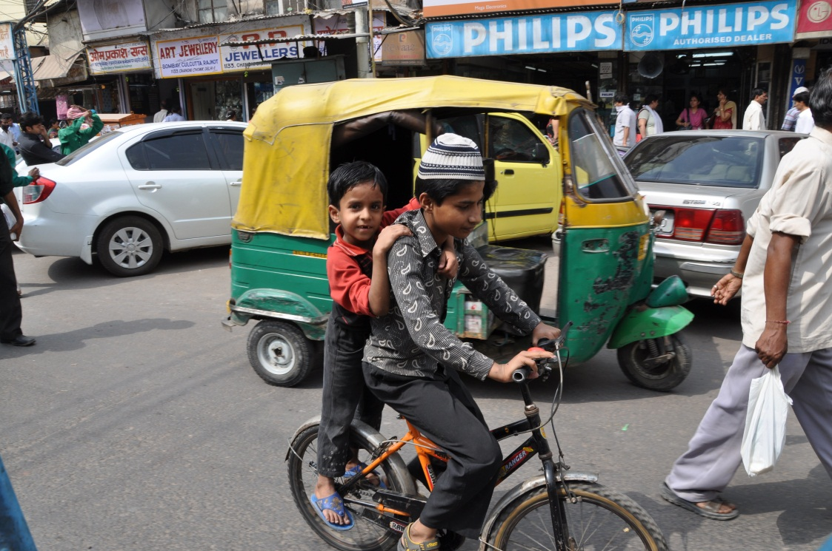
- Avoid public transportation.
- Use your TMC or Uber to hire a car or cab – it’s traceable.
- In limos and taxis sit behind and opposite your driver. You should be able to make eye-contact with him during the drive.
- Always wear a seatbelt.
- Don’t leave interior lights on when traveling at night.
- Stow brief cases, backpacks and valuables on the floorboard, not the seat.
- Keep doors locked, and windows up.
- Your driver should keep three car-lengths between cars ahead of you in traffic, and always leave ½ car length between you and the car in front of you at stoplights or stop-signs; on wider roads, the driver should stay in the outside or curbside lane, but never the middle.
- Your driver should always leave enough room to maneuver around other vehicles – during an emergency sidewalks and medians are fair game.

- In high risk locations use a “box” maneuver instead of making turns in front of oncoming traffic. In countries with left-hand drive (US, Germany, France) when you want to turn left, the box method requires you to cross your intended road, then execute three right-hand turns around the next block. This will put you on course without exposing your side of the car to oncoming traffic while it increases the probability that you will identify anyone who is following you.

Hotels
- Make change from big bills into useable denominations at your hotel – never change large bills at street vendors or in public locations.
- Don’t scatter your belongings in hotel rooms or vehicles. Keep your belongings organized and packed as much as possible in case you need to make a fast exit. Additionally – when you keep your room neat and organized, you’ll make it easier on the hotel staff. They’ll reciprocate which is especially helpful when you forget an item and leave it in your room – they’re much more likely to “find” it.
- Arrange your room to make a clear path to your door in case of darkness/power loss.
- Fill the peephole with a piece of toilet paper or tissue.
- In high risk areas keep one pair of shoes upside down with socks stuffed inside them on the side of the bed away from the window.
- Never take physical keys from a hotel off property – leave them with the hotel staff when you leave.

Out and About
- Avoid jewelry or flashy watches. Your shoes, hairstyle, and clothing set you apart during international trips so reduce the other signs that mark you as an easy target.
- Never leave a hotel with a metal room key. Leave it with the concierge or front desk to let them hold it for you while you’re out. And don’t let the staff give you a keycard sleeve with your room number printed on it to hold your keys.
- Don’t keep your cash, ID’s, and Credit Cards in the same pocket. Use multiple pockets and spread things around.
- Never store your full data cards with your camera, put them somewhere else (but never in checked luggage). If you walk, don’t walk alone, especially after dark. Leave a note to yourself at the front desk that contains information about where you are going or who you will meet. This will give investigators a head start if you don’t return.
- Never read a map in public. Find a hotel lobby, retail store or restaurant to determine where you are and where you’re headed.
- Know local customs and signs that will get you in trouble. Some well-known advice includes carrying a “mugging” wallet with at least $100 USD in Argentina and Brazil, but in China you should increase your cash to >$300 in case you need to pay for emergency medical care.
- Keep your passport, credit cards, and other ‘chipped’ items in a faraday cage to remove their ‘electronic’ signature and make them invisible to chip readers.
- Make eye contact with people around you. Avoid texts, email and calls when you’re walking in an unfamiliar area – appear alert (Van Horne & Riley, 2014)
- Stay dry.
- Cover open cuts.
- Assume insects are harmful – don’t let them bite you. Use insecticide and wear long-sleeved shirts and long pants.
- When working outside do not use deodorant, but if you must, use a fragrance-free version. This will reduce your attractiveness to many insects.
- Stay hydrated, rested and avoid heavy alcohol consumption.
- If you’re approached by a stranger expect them to have a partner. It’s not usually the person who approaches you first who is your greatest threat.
- Be polite but firm in unsolicited conversations.
- At sporting events, use less-crowded, side-entrances.
- Avoid spending more time than necessary in high-profile public spaces. Arrive to events well before the crowds or after they have subsided.
- Be alert.
- Don’t fall in love with anything you own – be prepared to leave it behind.

Bibliography
Archives, T. N. (2014, July 17). Corporate Manslaughter and Corporate Homicide Act 2007. Retrieved July 17, 2004, from legislation.gov.uk: http://www.legislation.gov.uk/ukpga/2007/19/contents
Blum, D. (2010). The Poisoner's Handbook. New York: The Penguin Press.
EU. (2009, August 14). Duty of Care. Retrieved July 17, 2014, from eurofound.europe.eu: http://www.eurofound.europa.eu/emire/GERMANY/DUTYOFCARE-DE.htm
EU. (2009, August 9). Duty of Loyalty. Retrieved July 17, 2014, from Eurofound.europe.eu: http://www.eurofound.europa.eu/emire/GERMANY/DUTYOFLOYALTY-DE.htm
Hope, C. (2009, November 26). http://www.telegraph.co.uk. Retrieved from Telegraph.co.uk: http://www.telegraph.co.uk/news/worldnews/asia/india/6645178/Revealed-how-Mumbai-terrorist-attacks-nearly-wiped-out-top-management-at-Unilever.html
Larkin, T., & Ranck-Buhr, C. (2009). How to Survive the Most Critical 5 Seconds of you Life. Sequim, Washington: TFT Group.
Levitt, S. D., & Dubner, S. J. (2009). Freakonomics. New York: HarperCollins Publishers.
Meyer, E. (1998). Chemistry of Hazardous Materials. Upper Saddle River: Prentice-Hall, Inc.
Oatman, R. L. (2006). Executive Protection, New Solutions for a New Era. Baltimore: NobleHouse.
Park, K., & Weiss, R. (2014, July 18). Malaysian Air Flight Took Route Avoided by Qantas, Asiana. Retrieved July 18, 2014, from Bloomberg.com: http://www.bloomberg.com/news/2014-07-18/malaysian-airline-took-flight-route-avoided-by-qantas-asiana.html
Richards, D. (2010, September). Relationship between Speed and Risk of Fatal Injury: Pedestrians and Car Occupants. Retrieved July 2014, from assets.dft.gov.uk/publications: http://assets.dft.gov.uk/publications/pgr-roadsafety-research-rsrr-theme5-researchreport16-pdf/rswp116.pdf
Ripley, A. (2008 ). The Unthinkable, Who Survives When Disaster Strikes - and Why. New York: Crown.
Sherwood, B. (2009). The Survivors Club, The Secrets and Science that Could Save Your Life. New York: Grand Central Publishing.
Telegraph. (2011, february 17). What is corporate manslaughter? Q&A. Retrieved July 17, 2014, from Telegraph.co.uk: http://www.telegraph.co.uk/finance/yourbusiness/8331177/What-is-corporate-manslaughter-QandA.html
US Army Infantry School. (n.d.). Field Manual 7-8, Infantry Rifle Platoon and Squad. Fort Benning: United States Army.
Van Horne, P., & Riley, J. A. (2014). Left of Bang. New York: Black Irish Entertainment LLC.

Cover photo by Bruce Handy – The Coney Island Parachute Drop at sunrise on July 4, 2014.

About the author:
Paul Laherty is Diio LLC’s, Vice President, Sales. Diio is a market leading provider of business intelligence software for airlines and airports and a tClara partner. Paul helps airlines increase revenue and reduce costs through better forecasting, financial analysis and scenario modelling.

Prior to his role at Diio, he led corporate sales for Cornerstone Information Systems, developed Travelocity’s airline strategy, and ran the America’s Air and Hotel consulting teams at Advito. Paul started his corporate travel career with American Airlines where he managed teams in sales, marketing and finance including the global corporate contracts team. Paul also re-launched and transformed American’s business loyalty program, Business Extra, and introduced the first corporate loyalty credit card with American Express.

Paul served in the United States Army, as a Platoon Leader and Company Executive Officer in Military Police Companies in Korea and Fort Polk, Louisiana. He holds both an MBA and a BS from Indiana University. Paul lives in Southlake, Texas with his wife and two daughters and flies a Cherokee 140 as often as time allows. He also hosts “Trends in Travel Management” and is active on LinkedIn and Twitter @paul_laherty.

