2018 Conference
By Higher Education.
For Higher Education.
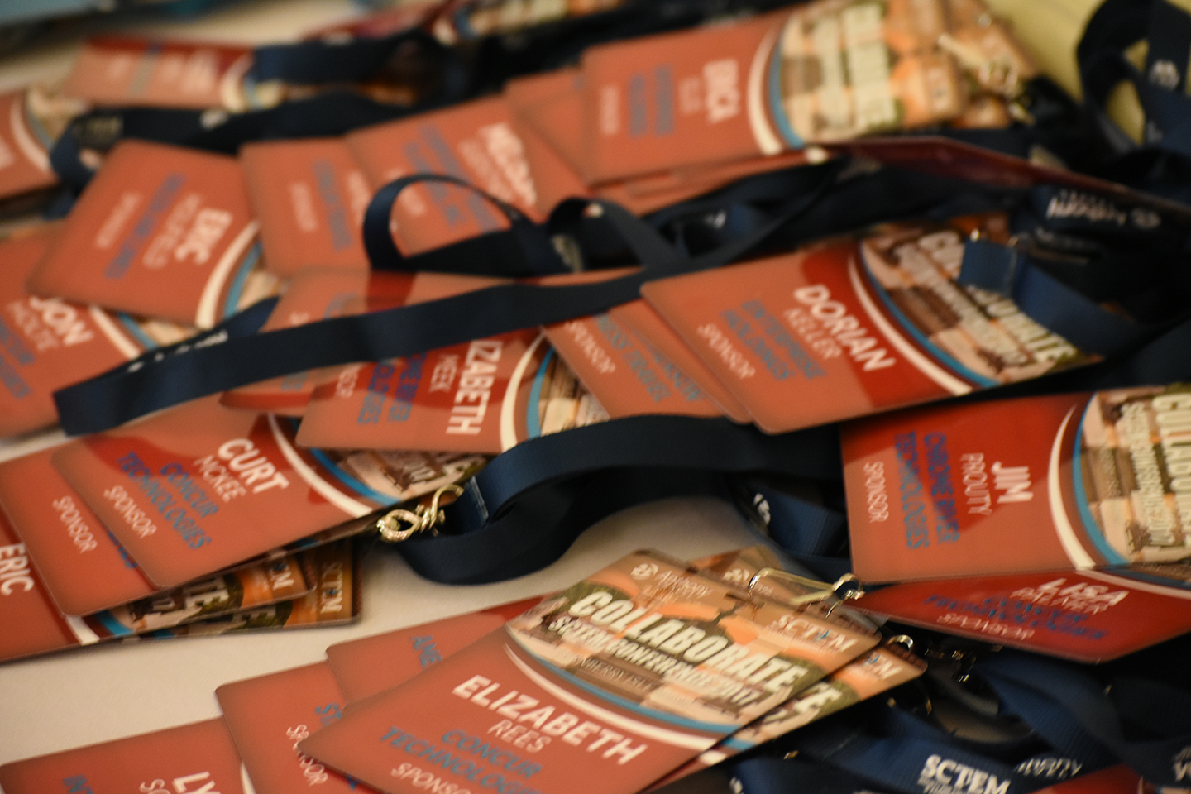

Diamond (SOLD)
$25K: Keynote Session Speaker: By sponsoring our keynote speaker, Sponsor is provided opportunity to introduce speaker with 2 minute speech on their product/service (“elevator speech”); acknowledged as our top sponsor for the conference; Digital Marketing Package - Diamond; 5 free registrations; Table at Vendor Speed Dating; trade show table.
Platinum
$20K: Dinner (1 available): By sponsoring dinner, Sponsor is provided opportunity to host the dinner (meet & greet) and give 2 minute speech on their product/service (“elevator speech”) during dinner; acknowledged as one of our top sponsors for the conference; Digital Marketing Package - Platinum; 4 free registrations; Table at Vendor Speed Dating; trade show table.
Gold
$15K: Lunch (1 available): By sponsoring this package, Sponsor is provided opportunity to host the lunch (meet & greet) and give 2 minute speech on their product/service (“elevator speech”) during lunch; acknowledged as one of our top sponsors for the conference; Digital Marketing Package - Gold; 3 free registrations; Table at Vendor Speed Dating; trade show table.
Silver
$10K: Break-out Session Sponsor (5 available): This sponsorship funds a scholarship for an educational session speaker. Sponsor is provided opportunity to introduce speaker with 2 minute speech on their product/service (“elevator speech”); acknowledged as a sponsor for the conference; Digital Marketing Package - Silver; 2 free registrations; Table at Vendor Speed Dating; trade show table.
Bronze
$5K: Breakfast (1 available): By sponsoring this package, Sponsor is provided opportunity to host the breakfast (meet & greet) and give 2 minute speech on their product/service (“elevator speech”) during breakfast; acknowledged as one of our sponsors for the conference; acknowledged as sponsor for the conference; Digital Marketing Package - Bronze; 1 free registration; Table at Vendor Speed Dating; trade show table.
$5K: New Attendee Reception (0 available): By sponsoring this package, Sponsor is provided opportunity to host the Reception (meet & greet) and give 2 minute speech on their product/service (“elevator speech”) during the Reception; acknowledged as one of our sponsors for the conference; Digital Marketing Package - Bronze; 1 free registration; Table at Vendor Speed Dating; trade show table.
$5K: Reception (0 available): Receptions are the 45 – 60 minutes prior to dinner each night. By sponsoring this package, Sponsor is provided opportunity to host the Reception (meet & greet) and give 2 minute speech on their product/service (“elevator speech”) during the Reception; acknowledged as one of our sponsors for the conference; Digital Marketing Package - Bronze; 1 free registration; Table at Vendor Speed Dating; trade show table.
$5K: Conference Bags (0 available): By sponsoring the conference bags, Sponsor will have their company logo on the bags which will be provided to all attendees; acknowledged as one of our sponsors for the conference; Digital Marketing Package -Bronze; 1 free registration; Table at Vendor Speed Dating; trade show table.
$5K: Wednesday Excursion TBD (1 available):
Sponsor
$3K: Trade Show & Break (2 available): By sponsoring this event, sponsor is provided opportunity to host a trade show and break; acknowledged as one of our sponsors for the conference; trade show table.
Vendors are encouraged to invite/sponsor EDU attendees. Your current clients add value by: 1) bridging relationships between vendors and potential EDU clients, 2) marketing your product/service by providing in person testimonials.

Digital Marketing Opportunities with SCTEM Sponsorship Packages:
Webinar – Diamond (Sold), Platinum (3)
Provide a co-branded webinar aimed at higher education with exclusive sponsorship within the webinar, promoted by SCTEM to all members, subject to content review by board of directors. The one-hour webinar topic will be developed based on an important topic that the supplier member has expertise in and that matches up to a topic of interest for higher education travel and expense management. Webinar content needs to be tailored to a higher education audience. Supplier partner can promote webinar to their higher education clients and prospects. SCTEM will promote this to the entire SCTEM membership via social media, web site and e-mail marketing.

Whitepaper – Diamond (Sold), Platinum (3)
Provide a co-branded whitepaper aimed at higher education audience with exclusive sponsorship within the whitepaper, content produced will be around collaboration with a higher education partner, promoted to all SCTEM members subject to content review by SCTEM board of directors. Could be higher education case study or best-practices for higher education model. Approximately 3-10 pages in length. Supplier partner can promote case / whitepaper to their higher education clients and prospects, SCTEM will promote this to the entire SCTEM membership via social media, web site and e-mail marketing.

Sponsored Article (blog) - Diamond (Sold), Platinum (3), Gold (2)
Provide a 1000 word content article aimed at higher education audience with exclusive sponsorship within the blog/article, content produced should be best practices or exploring a collaboration with a higher education partner. SCTEM will promote this to the entire SCTEM membership via social media, web site and e-mail marketing, supplier may promote this to their higher education clients and prospects.

Sponsored E-mail – Diamond (Sold), Platinum (3), Gold (2)
Provide a sponsored logo on SCTEM’s regular e-mail communication to all members. Includes supplier member logo plus “Diamond, Platinum or Gold Sponsor of SCTEM Collaborate 2018 Conference” logo. This includes a callout and link to the supplier’s web site landing page. E.g. Sponsor logo plus a message aimed at higher education.

Sponsored web site sections
Tier 1 – Premium resources/blog – Diamond
Includes supplier member logo plus “Diamond Sponsor of SCTEM” logo to appear on blog/resources section header and/or sidebar

Tier 2 – Major web site sections aimed at Higher Ed (Diamond, Platinum and Gold, depending on placement)
Includes supplier member logo plus “Diamond, Platinum or Gold Sponsor of SCTEM” logo to appear on blog/resources section header and/or sidebar

Tier 3 – Other section of web site (Bronze or Silver, depending on placement)
Includes supplier member logo to appear on blog/resources section header and/or sidebar (except for premium Tier and Tier 2 pages)

All content offers, webinars and whitepapers are subject to content review by SCTEM board of directors. Supplier members should submit a logo no smaller than 500 pixels wide, and in a transparent .png format. If you’re unsure, submit a vector EPS file and SCTEM will make the conversion. Please indicate what package you have elected and send your logo to digitalmarketing@sctem.org.

